F.N.S.A. OCTOBER 2012 – NEWSLETTER

FROM THE VICE PRESIDENT

MALAYA AND BORNEO VETERANS DAY

It may be of interest to those who served on HMAS SYDNEY to Jesselton in 1964 and on other ships that served in the FESR during the Malayan Emergency and the Confrontation with Indonesia, that the 31st of August is now officially in the Military Calender as Malaya and Borneo Veterans Day. A nominal roll of those who served, similar to the Korean and Vietnam Rolls is being prepared.
Don’t know when it will come about as it took a few years and a lot of hard work by those (mainly Army and Air Force) in the NMVBAA Office to get agreement from Department of Defence for this day to be recognised.

Allan Moffatt
HMAS ANZAC 1957 -58 Malayan Emergency
HMAS SNIPE 1965-66 Borneo- Indonesian Confrontation

BATTLE FOR AUSTRALIA SERVICE:

The Service was held at the Cenotaph, Martin Place on 5th September and commenced at 11 am. The Governor of NSW, Her Excellency Professor Mare Bashir AC CVO was piped in by Pipers from Scots College then the Cataflaque Party and Flag Orderlies took post. A Hercules C130 flew very low at 11.05 in memory of the “biscuit bombers” from the battles in New Guinea. The Guest Speaker was Mr. Keith Pryor ex Merchant Navy and had served aboard the MV Mandurah hospital ship during the War. His history of the events and the loss of merchant shipping off the coast of Australia was very good to listen to.

At the Wreath Laying, sprigs of wattle were laid instead of a Wreath. The singing of the 23rd Psalm was sung by the Choir of St. Andrews Cathedral School and was indeed a pleasure to listen to.

FROM THE SECRETARY

On Sunday, 14th October was our Annual Church Service at Garden Island. This was combined with the Plaque Dedication Ceremony and was very moving. We had about 160 families, friends and Associations’ Members there. It was especially significant to me as a plaque was dedicated for my Father (PO Charles Nelson). Morning tea after at the Naval Historical Society’s building went off well with people spilling outside. All in all, a very good day.

The next F.N.S.A. Meeting will be 15th November 2012 at the Combined Services Club, Barrack Street commencing at 10.45am

There’s a few articles of interest in this issue of the Newsletter so enjoy.

As this will be the last Newsletter this year, I would like to wish everyone a safe and happy Christmas and New Year. (It’s come around too fast!)

THE NEXT FNSA MEETING
IS
15th NOVEMBER 2012 COMMENCING AT 10.45
THE COMBINED SERVICES CLUB, BARRACK ST. SYDNEY

BITA PAKA DAY

This article was written by Ian Pfennigwerth.

As you work your busy way through today I hope that you can find a few moments thinking of the members of the RAN and RANR who were landed on the jetty at Kabakaul in New Britain from the cruisers and destroyers of the Australian Fleet at dawn 98 years ago. Their task was to find the German radio station somewhere in the vicinity and to capture it. They did not know where it was not how well defended it might be. Resistance was expected, although they themselves were only lightly armed: if they ran into difficulties they had no way of communicating the fact and seeking assistance except by runner. There must have been a few nervous gulps as they chambered live rounds in their pistols and rifles that morning and set off down a likely-looking road, fringed with dense jungle, into the growing heat of a tropical day. The Royal Australian Navy was about to fight its first battle with Imperial Germany, not at sea but on land.

The action that developed at Bita Paka called for initiative and improvisation, as German defences were identified, snipers encountered and casualties taken by the landing party. Reinforcements were summoned and bluff and determination carried the day, but not before five Australians had died. The final phase took place as dusk was falling. Australia’s first military action under the new Commonwealth flag was a victory, and one of considerable strategic consequences for Australia and Germany. Lieutenant Thomas Bond RANR won Australia’s first DSO that day, and Able Seaman Billy Williams RANR of Northcote in Victoria, sadly, was the first Australian to lose his life in WW1.

You might also reflect on why it is the RAN and naval veterans organisations don’t commemorate the anniversary of this battle with its sacrifice and heroism. It and founded a tradition and set a standard of devotion to duty which successive generations of Australian Navy people have upheld in all corners of the globe, and do so to this day. And finally, if you have the opportunity, you might share the story with another Australian; we all should know and be proud of the achievement of those officers and sailors from the Australian Fleet who set
off into the unknown from Kabakaul at dawn 98 years ago today to do battle for their country.

Lest we forget,

Ian Pfennigwerth

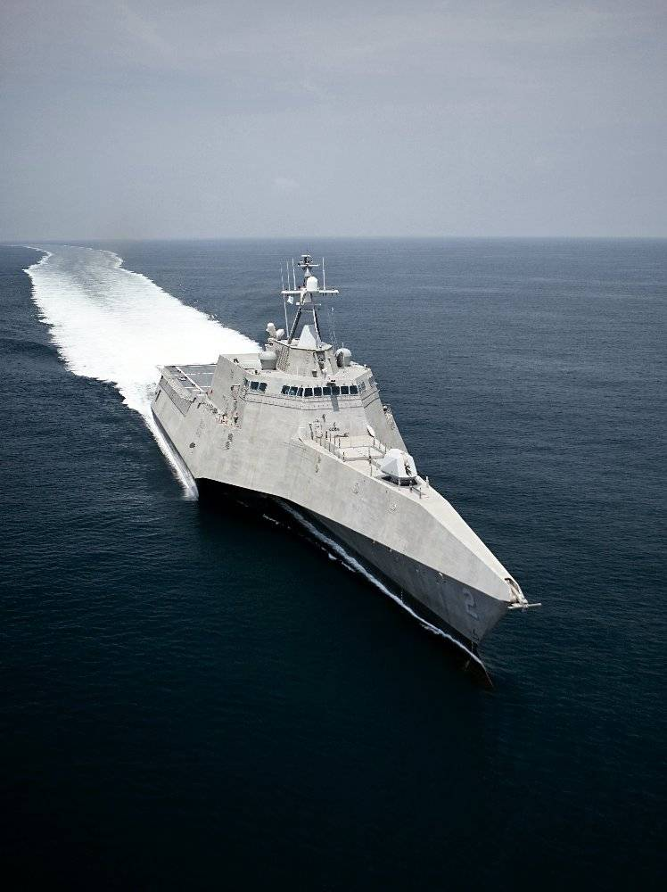
The U.S. Navy’s New Pirate Catcher is an INCAT designed & built in W.A. Half speed 43 knots. It is being tested for a worldwide multi-purpose ship

“AIR WARFARE DESTROYER UPDATE

Minister for Defence Stephen Smith, Minister for Finance and Deregulation Senator Penny Wong and Minister for Defence Materiel Jason Clare on the 6th September 2012, attended the laying of the keel of the first Air Warfare Destroyer (AWD) in Adelaide and provided an update on the $8 billion project.

Australia is constructing three AWDs based on a proven design from the Spanish Navy. When complete, the Destroyers will be amongst the world’s most capable warships.

The Air Warfare Destroyer project is currently the largest Defence procurement project in Australia. Almost 2,500 people are employed directly on the AWD project throughout Australia, including a national AWD shipyard production workforce of more than 1,500 people in Adelaide, Newcastle and Melbourne.

Construction of the AWDs involves the fabrication of 90 separate steel blocks, 30 for each ship, as well as three sonar blocks, one for each ship at a number of shipyards in Australia and overseas.

ASC in Adelaide is the principal shipbuilder in the project. BAE Systems in Melbourne, Forgacs in Newcastle and Navantia in Spain are also building blocks.

These blocks will be brought together by ASC at the South Australian Government’s Common User Facility in Adelaide where ships are being assembled.

BACKGROUND ON THE AIR WARFARE PROJECT

The AWD project is currently the largest defence project in Australia and has grown and developed industry capability and skills in the naval shipbuilding sector Australia-wide for future naval shipbuilding projects.

The project is also developing the skills and infrastructure to sustain the warships during their service life.

The AWDs will provide greater protection for Australian Defence Force personnel by providing area defence for accompanying ships as well as land forces and infrastructure on proximate coastal regions.

The AWDs will be interoperable with international partners and capable of carrying out multi-mission operations ranging from high-intensity conflict to search and rescue.

They will be layered defensive and offensive capability to provide air and surface defence to Australian troops close to shore; anti-submarine and anti-surface warfare capability; the ability to embark a helicopter at sea and the ability to escort a fleet.

The Government and Defence have been actively working with Defence Industry and the AWD Alliance which is managing the AWD project to deliver the project. The AWD Alliance consists of ASC, the Defence Materiel Organisation (DMO) and Raytheon Australia.”

Excerpts from the Minister for Defence News Release dated 6th September 2012.
LAW OF RANDOM NUMBERS. If you dial a wrong number, you never get a busy signal; someone ALWAYS answers.

HMAS SYDNEY II ANNUAL MEMORIAL SERVICE

The Annual Service will be held on Monday, 19th November, 2012 commencing at 11 am at the Cenotaph, Martin Place.
There will be a luncheon at 99 on York (formerly The Bowlers Club) afterwards at a cost of $45.00pp. If interested, please contact Mary Bell on 9670 4025.

“UPDATE ON THE FUTURE SUBMARINE CAPABILITY

Minister for Defence Stephen Smith, Minister for Finance and Deregulation Senator Penny Wong and Minister for Defence Materiel Jason Clare today announced Australia’s Future Submarine Systems Centre will be based in Adelaide continuing the strong relationship that has been formed between South Australia and the Commonwealth in support of Australia’s maritime sector.

The Systems Centre will be the home of the Future Submarine program. It will be formally established this year and over the next few years will expand to include hundreds of Defence personnel from Navy, the Defence Materiel Organisation, the Defence Science and Technology Organisation (DSTO) and the Australian and international Defence Industry.

The Systems Centre is a similar facility to the one that was established for the Air Warfare Destroyer project. It will undertake a variety of tasks including evaluation of options, design work, program management, engineering, logistics and production planning.

The Government is committed to acquiring 12 new submarines to be assembled in South Australia.

This commitment will be reinforced as part of the 2013 Defence White Paper.”

HMAS PARRAMATTA ANNUAL MEMORIAL SERVICE

The Service will be on Sunday 25th November 2012 at 1400 hrs. at the Queens Wharf Reserve, George St. Parramatta.
There will be a short march from the Gas Works Bridge to the Memorial and if raining, the Service will be held in the Parramatta RSL Club with light refreshments afterwards.
Excerpts from the Minister for Defence News Release

IFR 2013 - Participating Tall Ships
From the RAN Web Page News. More ships in the next issue.

STS Young Endeavour
Australia's national sail training ship Young Endeavour is the gift given to the people of Australia by the United Kingdom on the occasion of the Bicentenary in 1988. The then Prime Minister dedicated Young Endeavour to "... to the benefit of the young people of Australia", and the ship has operated with this guiding principle ever since.
Young Endeavour is a brigantine, designed by Colin Mudie and laid down by Brooke Marine in 1986. She was launched on 2 June 1987 and on 3 August that year sailed from Lowestoft, England to Sydney, Australia, with a crew of ten staff and 24 youth from Great Britain and Australia. The ship's motto is "carpe diem", Latin for "seize the day'.
Each year Young Endeavour delivers a challenging program of youth development voyages for young Australians aged 16 to 23 years, and a program of day sails for youth with special needs. 24 young Australians join each eleven day voyage, usually sailing from ports in Queensland, New South Wales, Victoria, Tasmania and South Australia.
Young Endeavour has circumnavigated Australia three times, in 1995, 2001 and 2009, visited Indonesia in 1995, and has sailed to New Zealand twice, in 2000 and 2006. Young Endeavour also sailed around the world in 1992, visiting places including Egypt, Turkey, Greece, France, Italy, Spain, the United States of America, the Bahamas, Tahiti and New Caledonia.
A voyage in Young Endeavour empowers young Australians, increasing self awareness, developing teamwork and leadership skills, and creating a strong sense of community responsibility. Since 1988 over 11,000 young Australians have participated in the Young Endeavour Youth Development Program and another 10,000 youth have joined a Young Endeavour Community Day Sail.
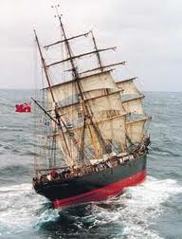

James Craig
Built in 1874 in Sunderland, England, by Bartram, Haswell, & Co., she was originally named Clan Macleod. She was employed carrying cargo around the world, and rounded Cape Horn 23 times in 26 years. In 1900 she was acquired by Mr J J Craig, renamed James Craig in 1905, and began to operate between New Zealand and Australia until 1911. Unable to compete profitably with freight cargo, in later years James Craig was used as a collier. Like many other sailing ships of her vintage, she fell victim to the advance of steamships, and was first laid up, then used as a hulk, until eventually being abandoned at Recherche Bay in Tasmania. In 1932 she was sunk by fishermen who blasted a 3-metre hole in her stern.
James Craig is currently berthed at Wharf 7 of Darling Harbour, near the Australian National Maritime Museum. She is open to the public, and takes passengers out sailing on Sydney Harbour and beyond. She is crewed and maintained by volunteers from the Sydney Heritage Fleet.
James Craig is of exceptional historical value in that she is one of only four ships of her era and rig, still afloat and putting to sea fortnightly when not on voyages to Melbourne or Hobart. As such she is a working link to a time when similar ships carried the bulk of global commerce in their holds. Thousands of similar ships plied the oceans in the 19th and early 20th centuries linking the old world, the new world, Asia and Oceania. She is sailed in the traditional 19th Century manner entirely by volunteers from the Master to the galley crew.
The James Craig picture below.

